**Filter**

Using regex pattern: (?i)путин[а-я]*|владимир\\s*владимирович\\s*путин|владимир\\s*путин

* **путин[а-я]\*** matches variations of the word "Путин" with any sequence of Russian letters following it.
* **владимир\\s*владимирович\\s*путин** matches the phrase "Владимир Владимирович Путин" where the name "Владимир" and "Путин" are separated by optional whitespace characters (**\\s\***). This pattern accounts for the full name of Vladimir Putin including his patronymic "Владимирович."
* **владимир\\s*путин** matches the phrase "Владимир Путин" where the name "Владимир" and "Путин" are separated by optional whitespace characters.

These decisions are made to capture the name “Putin” (путин) including all sorts of conjugations that can occur at the start and at the end of the word in Russian. In addition, we capture various combinations of Vladimir Putin.

**Bloggers**

You can also find the list here under “currently in sample”: <https://uio-my.sharepoint.com/:x:/r/personal/egnilsen_uio_no/_layouts/15/Doc.aspx?sourcedoc=%7B62626C20-8EA0-4F10-9AAE-12A742E40DA3%7D&file=urls.xlsx&action=default&mobileredirect=true>

Bloggers: aleksandr_skif, anna_news, bolshiepushki, boris_rozhin, epoddubny, ghost_of_novorossia, grey_zone, neoficialniybezsonov, opersvodki, readovkanews, RKadyrov_95, rsotmdivision, russ_orientalist, rybar, sashakots, Sladkov_plus, strelkovii, swodki, vladlentatarsky, vysokygovorit, wagnernew, warfakes, wargonzo, wehearfromyanina

Total bloggers: 24

**Posts**

|  |  |
| --- | --- |
| **Subsampling step** | **Number of posts** |
| Original | 841409 |
| Removed Soloviev | 676014 |
| Removed missing | 497780 |
| Wartime posts | 353129 |
| Pasted | 339846 |
| Putin mentioned | 9369 |

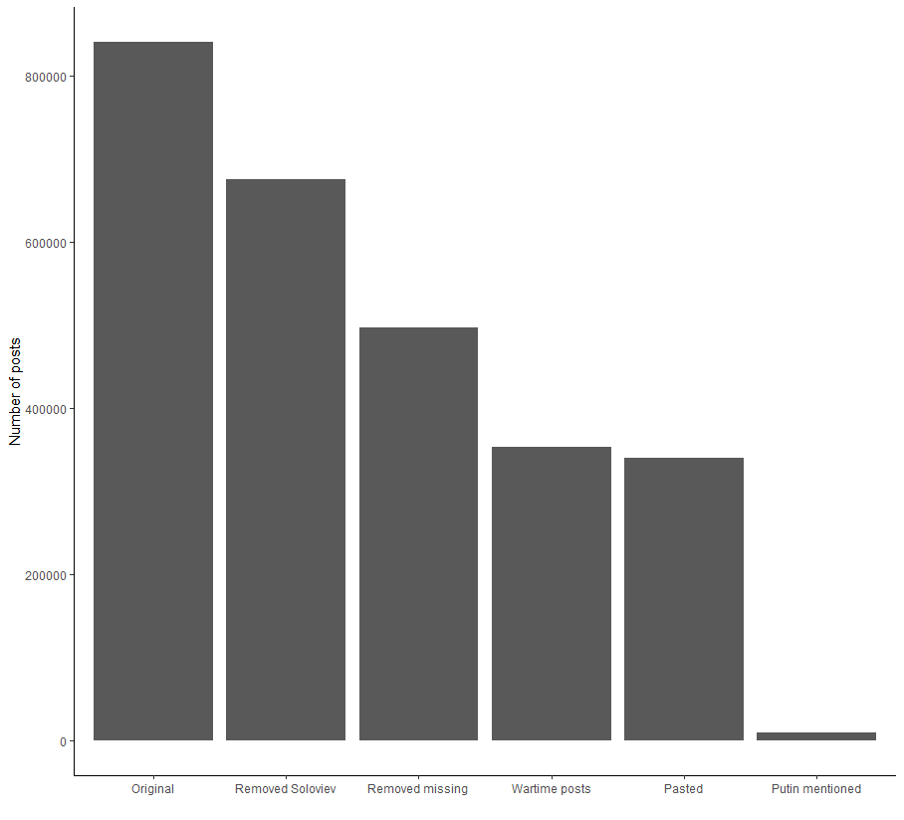

**Time frame**

01.01.2022 to 04.30.2023